MONDAY 27TH OCTOBER

TODAY YOU CAN HELP CARVE CRAZY PUMPKINS,
BAKE A GRUESOME EDIBLE EYEBALL AND PLAY PIN
THE PIMPLE ON THE WITCH.
TUESDAY 28TH OCTOBER

YOU CAN MAKE A BUBBLING CAULDRON PICTURE
AND BAKE DOUGHNUT MONSTER FACES. ENJOY A
GAME OF WHO STOLE THE PUMPKIN TOO.

WEDNESDAY 29TH OCTOBER
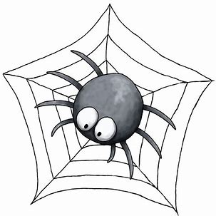
HAVE A GO AT MAKING A PUMPKIN FACE CHANGER
AND BAKING A CRACKLING, TOXIC JELLY CAULDRON
TODAY. YOU CAN PLAY SPIDER AND FLY AS WELL.

THURSDAY 30TH OCTOBER
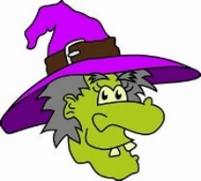
MAKE A PAPER PLATE APPEARING GHOST AND
BAKE PUMPKIN BISCUITS. HAVE FUN PLAYING OUR
HALLOWE’EN DRESS-UP CHOCOLATE GAME TOO.
FRIDAY 31ST OCTOBER

HAPPY HALLOWE’EN! IT’S A PARTY DAY! COME DRESSED UP! WE’LL PLAY PARTY GAMES AND MAKE CRAFTY BATS. FOR AN ADDITIONAL £5.00, WE’LL PROVIDE PARTY FOOD, A CREEPY FACE/ARM PAINTING SESSION AND A SPOOKY GOODIE BAG!
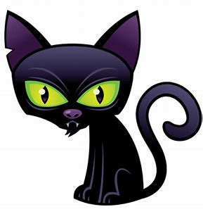

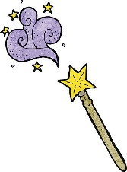

COME AND JOIN US FOR A SPOOKY THEMED HALF TERM WEEK!

Prices and session times are as follows: 8:30 AM until 3:15 PM - £18.00 (Includes breakfast and a mid-morning snack.) 8:30 AM until 5:30 PM - £24.50 (Includes breakfast, a mid-morning snack and an afternoon snack.) We require one week’s notice to cancel a place. Please make sure your child has a packed lunch with them (including a drink) except for the party day if you would like us to provide the additional £5.00 extras.

LINDHEAD OUT OF SCHOOL CLUB Ofsted registered EY442229 / Charity Number 1122450 Phone 871861 or Email thedenburniston@btconnect.com

